**WHAT DOES IT TAKE**

**TO BE SUCCESSFUL?**

* **Daily attendance and punctuality**
* **Commitment to hard work**
* **Eager to learn**
* **Positive attitude**
* **Cooperation**
* **Creativity**
* **Problem-solving**
* **Desire to perform quality work**
* **Reading Comprehension, Math, Algebra & Science principles**

**QUALIFICATIONS &**

**REQUIREMENTS?**

* **18 years of age**

*Opportunities available for high schoolers in youth apprenticeship*

* **Valid driver’s license**
* **High School Diploma or GED/HSED**

*From state-approved institution*

* **Pass a qualifying exam**
* **Meet with the JAC to receive a Letter of Introduction**
* **Find an approved plumbing company to hire you**
* **Pass a 3rd-party drug screen**

**HOW DO I**

**GET STARTED?**

**Visit our website at**

[**www.plumbers75.com**](http://www.plumbers75.com)

**and under**

***“Discover Apprenticeship”***

***“START YOUR CAREER PATH”***

**register to receive detailed information on the application process for your area.**

***A REWARDING CAREER STARTS RIGHT HERE!***





***TRAINING TO***

PROTECT

***THE***

HEALTH

***OF THE***

NATION

**PLUMBERS LOCAL 75**

**Education & Apprenticeship**

**414-359-1318**

**www.plumbers75.com**

*The Milwaukee Area Joint*

*Plumbing Apprenticeship Committee*

*and the*

*Madison Area Plumbing*

*Joint Apprenticeship Committee*

*are*

*Equal Opportunity, Affirmative Action organizations.*

*Upon reasonable notice, efforts will be made to*

*accommodate the needs of individuals with disabilities.*

4/2021

PLUMBING

APPRENTICESHIP

* **Physical and hands-on**
* **Pride in building America**
* **A career where you see direct results**

[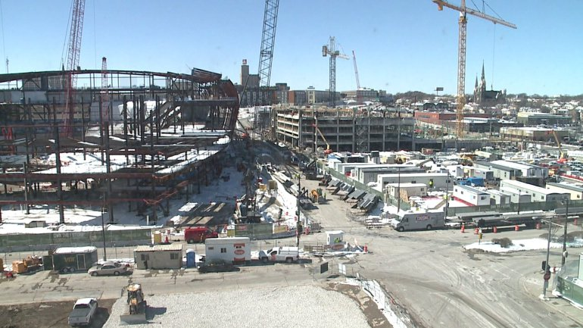](http://www.google.com/url?sa=i&rct=j&q=&esrc=s&source=images&cd=&cad=rja&uact=8&ved=0ahUKEwjz4IXmw8XTAhUI2oMKHeq_CTkQjRwIBw&url=http://fox6now.com/2017/03/30/johnson-controls-1st-major-sponsor-of-new-bucks-arena-named-official-smart-building-partner/&psig=AFQjCNF4vzl10xqbnj4M-rBQ16-fIjBjJg&ust=1493413119908322)

* **Long-term earning potential at family-sustaining wages and benefits**
* **Developing a lifetime skill**
* **Never boring, as work tasks and environments can change day to day**

**WHY PLUMBING?**

[](http://www.google.com/url?sa=i&rct=j&q=&esrc=s&source=images&cd=&cad=rja&uact=8&ved=0ahUKEwjO8-mtlcXTAhVm5YMKHeXMB7kQjRwIBw&url=http://lbmgmusic.us/water-filter-for-kitchen-sink.html&psig=AFQjCNEmAUYDi2JT15HSLsr_HHLlbk8bng&ust=1493400530152560)

* **Protects the health of the nation through clean drinking water & sanitary systems**

* **It’s a LICENSED trade in WI – not just anybody can call themselves a plumber**
* **Requires physical and mental readiness**
* **Intelligence & creativity are needed to troubleshoot**
* **Multi-faceted trade allows for growth and advancement in a high-tech industry *(Foreman, Master Plumber, Contractor, Instructor, Designer, Inspector, Consultant)***

**WHY CONSTRUCTION?**

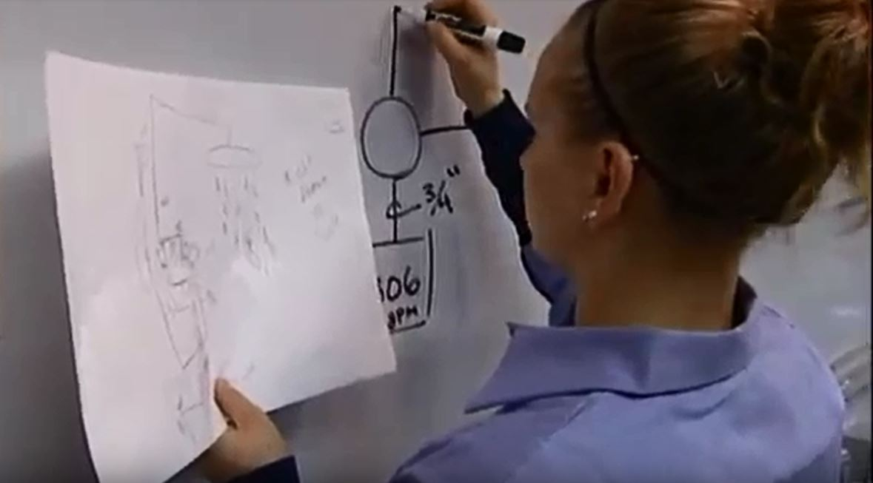

* **Earn while you learn**
* **B.A.S.-approved Contract with Milwaukee Area Joint Plumbing Apprenticeship Committee ensures quality training**
* **In-class instruction supplements and enhances**

**on-the-job learning**

* **Progressive schedule for wage increases over the term of the Contract**
* **State and national recognition of your competencies**

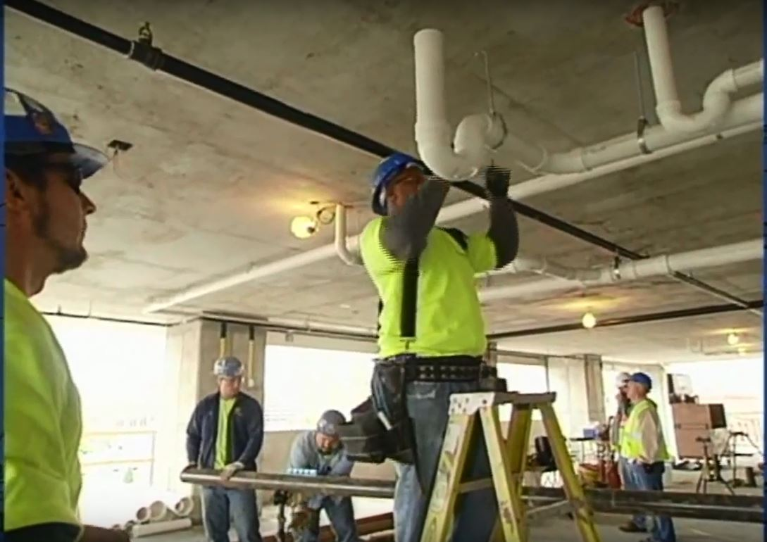

**WHY APPRENTICESHIP?**